“Seven Minutes of Terror,” Eight Years of Ingenuity
“Seven Minutes of Terror,” Eight Years of Ingenuity
“Sometimes when we look at it, it looks crazy,” remarked Adam Steltzner, an engineer who works for the National Aeronautics and Space Administration—known more commonly to the world as NASA. “It is the result of reasoned engineering thought. But it still looks crazy.”
In a video story entitled “Seven Minutes of Terror,” Steltzner was joined on camera by an eloquent cast of entry‐descent‐landing engineers (or “EDL Engineers”). Working from the Jet Propulsion Laboratory (JPL) in California, their team introduced the world to one of the most daring, inventive feats of engineering the world had ever witnessed: the pinpoint landing of NASA’s Curiosity rover on Mars.
The seven minutes explored in that story—and experienced by the world in early August 2012—took place after seven years of engineering, one year of space flight, and countless hours of collaboration on the perfect landing. Dubbed the Mars Science Laboratory (“MSL”), this mission brought together more than 7,000 people, working in organizations from all over the world, to accomplish its goals. Split into two parts, the launch and the landing, MSL is one of the greatest technological accomplishments of human history.
The most impressive thing about MSL is that no mission this ambitious had ever been attempted in the past. The landing presented problems that could not be compared directly to anything done before. But thanks to the rigorous work of hundreds of engineers, NASA ended up making a new mark on Mars.
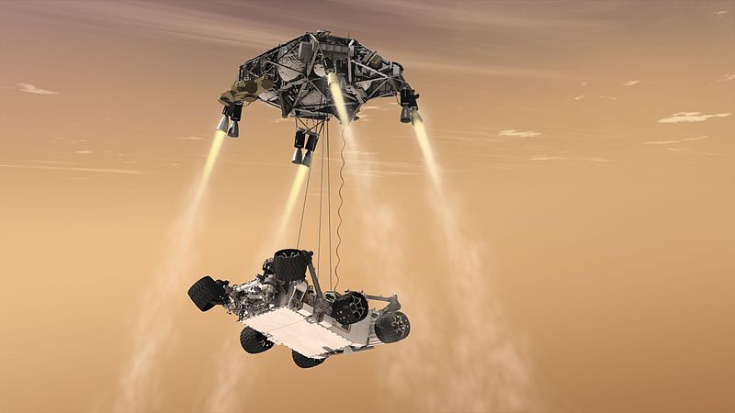
© 2013 ReadWorks®, Inc. All rights reserved.
“Seven Minutes of Terror,” Eight Years of Ingenuity
The Launch
The MSL launch took place on November 26, 2011. Blasting from the Earth at a speed of 12,582 miles per hour, the rockets that broke free of Earth’s orbit and sent the Mars‐bound spacecraft with the rover on its way were the most routine part of the mission. For decades NASA has specialized in space launches, drawing on some of the brightest minds on the planet to determine what it takes to bring a spacecraft to the stars.
Planning the rover’s trip to the red planet (Mars’s nickname, due to its color)—a voyage lasting about 36 weeks at maximum cruise velocity—was also not exactly a new challenge for engineers working on the MSL mission. NASA had already landed two rovers, named “Spirit” and “Opportunity,” on the surface of the red planet. Based on the principles of astronomy, the launch engineers at JPL had very precise requirements for making the journey from Earth to Mars.
The key to these requirements was an understanding of orbits. Although Mars is significantly farther from the sun than Earth, both planets orbit the same star. Their distance from each other changes during each cycle, but Earth comes into alignment with Mars once every 26 months—“lapping” it in a perpetual race around the sun. Observing this pattern, astronomers can work with engineers to pinpoint the optimal month, day, and time for a spacecraft to leave Earth on a speedy one‐way trip.
Drawing on centuries of knowledge of the laws of physics, scientists designed rockets and a spacecraft to accommodate Curiosity. Years of calculation, construction, careful planning and computer modeling resulted in a vessel that cruised purposefully through space, reaching the orbit of Mars at just the right time to attempt a landing.
Through it all, the margin for error was nearly non‐existent. The movement of interplanetary bodies in space is much more demanding than the movement of cars on a highway, or even airplanes in the stratosphere. Miscalculating a vector or failing to account for any aspect of the orbits could lead to a $2 billion failure.
Fortunately, NASA had taken on this challenge before. Its engineers had both the experience and the tenacity to succeed again. What came after the launch was a different story.
The Landing
Spirit and Opportunity, the two NASA rovers that landed on Mars in 2004, used a combination of parachutes, rockets, and hi‐tech airbags to protect themselves. Much like launch and spaceflight, each step of the landing sequence was planned and simulated to the very last
© 2013 ReadWorks®, Inc. All rights reserved.
“Seven Minutes of Terror,” Eight Years of Ingenuity
detail. Learning from a prior Mars mission, EDL engineers were able to recreate some of the same maneuvers used in that sequence.
Unfortunately, the specific requirements of MSL made it difficult to depend on past experience. While NASA had constructed the biggest supersonic parachute ever made, parachuting was far from enough. Since the atmosphere of Mars is 100 times thinner than the atmosphere of Earth, the parachute alone could not reduce the speed of descent past 200 miles per hour—a breakneck speed that would surely damage Curiosity upon landing.
Curiosity outweighed any earlier rover and contained over 150 pounds of sensitive scientific devices, so an airbag solution was ruled out. Instead, EDL engineers designed a maneuver that would allow the entry capsule to turn sharply and activate powerful rockets to finish the job. Once this maneuver was complete, the capsule could attempt a vertical landing.
Successfully executing the switch from a parachute entry to a controlled, rocket‐fueled descent was a feat that could have gone wrong at any moment. Still, even this was not enough to succeed. Once the parachute was cut, and a full radar system was online to guide Curiosity to the surface, the force from the rockets could kick up so much dust that the dust itself would damage the rover.
Eternally thinking one step ahead, EDL engineers designed a device called a “sky crane” to complete the final step of the landing sequence. When the sky crane was 20 feet above Martian soil, it lowered Curiosity onto the surface with a set of cables.
Moving from 13,000 miles per hour to zero miles per hour in just seven minutes, Curiosity finally touched down. The capsule, with all rockets still firing, blasted back into the sky and crash‐landed elsewhere on the planet. The landing was a success.
The Ongoing Mission
MSL is the latest of NASA’s attempts to learn more about Mars. The most popular inquiry is whether Mars may have, at any point in its long history, supported life as we know it. The search for these signs, however, is one piece of a much greater picture.
The mission has eight scientific objectives, each one broken into specific goals and all coming together to form a more detailed understanding of all things Mars. Curiosity, a rover the size of a station wagon, contains advanced instruments that will help it probe, sample, record, and analyze its way through Martian terrain. Collecting evidence on the biological, geological,
© 2013 ReadWorks®, Inc. All rights reserved.
“Seven Minutes of Terror,” Eight Years of Ingenuity
chemical, and radiological profile of the red planet will prepare NASA for the next space flight to Mars. Another rover mission, building on the work of Curiosity, is planned to launch in 2020.
Ultimately, scientists hope to learn enough about Mars to bring human beings to the surface for a manned research mission. Some, working with entrepreneur Elon Musk, are even devising a plan to colonize the planet just one decade later. Skeptics debate whether or not such a seemingly outrageous idea could ever be made into reality.
Looking back at NASA’s solutions to the great technical challenge of the Curiosity landing, it’s hard to feel too skeptical about humankind’s ability to reach for the stars.
© 2013 ReadWorks®, Inc. All rights reserved.
Questions: “Seven Minutes of Terror,” Eight Years of Ingenuity
Name: _____________ Date: _______________________ 1. What is Curiosity?
A a parachute used to land on Mars B another name for the National Aeronautics and Space Administration C aspaceroverthatlandedonMars D a video made by NASA engineers
2. What sequence of events is described in this passage?
A the sequence of events that led to Opportunity landing on Mars B the sequence of events that led to Curiosity landing on Mars C thesequenceofeventsthatledtothecreationofNASA D the sequence of events that will need to take place for Mars to be colonized
3. In order to land on Mars, Curiosity had to use a parachute, rockets, and a sky crane. What can be concluded from this information?
A Landing on Mars is a simple process. B Landing on Mars is a complicated process. C LandingonMarsisawasteoftime. D Landing on Mars in the future is unrealistic.
4. What helped make the Mars Science Laboratory mission successful?
A one person working by himself for decades B two countries competing with each other C alotofpeopleworkingtogetherforyears D hi-tech airbags first used in 2004
5. What is this passage mainly about?
A a mission to Mars B life on Mars C whatbeinganengineerislike D the history of NASA
1
© 2013 ReadWorks®, Inc. All rights reserved.
Questions: “Seven Minutes of Terror,” Eight Years of Ingenuity
6. Read the following sentence: “The mission has eight scientific objectives, each one broken into specific goals and all coming together to form a more detailed understanding of all things Mars.”
What does the word “mission” mean?
- A a problem that develops when people do not prepare for something as much as they should
- B a short period of time when people feel extremely nervous about something
- C themovementofinterplanetarybodies
- D an important task to be carried out by a person or group of people
7. Choose the answer that best completes the sentence below. Engineers spent years getting Curiosity ready; ______, it landed on Mars.
A finally B however C third D such as
8. Describe the video story “Seven Minutes of Terror.” ______________________________________________________________________
______________________________________________________________________
______________________________________________________________________
______________________________________________________________________
2
© 2013 ReadWorks®, Inc. All rights reserved.
Questions: “Seven Minutes of Terror,” Eight Years of Ingenuity
9. Which seven minutes of terror does the video’s title refer to? Support your answer with evidence from the passage.
______________________________________________________________________
______________________________________________________________________
______________________________________________________________________
______________________________________________________________________
10. Why might the engineers who worked on Curiosity have felt terror as they watched it land? Support your answer with evidence from the passage.
______________________________________________________________________
______________________________________________________________________
______________________________________________________________________
______________________________________________________________________
3

